**Setting Up Base Database Tables (This is required before starting up a new year)**

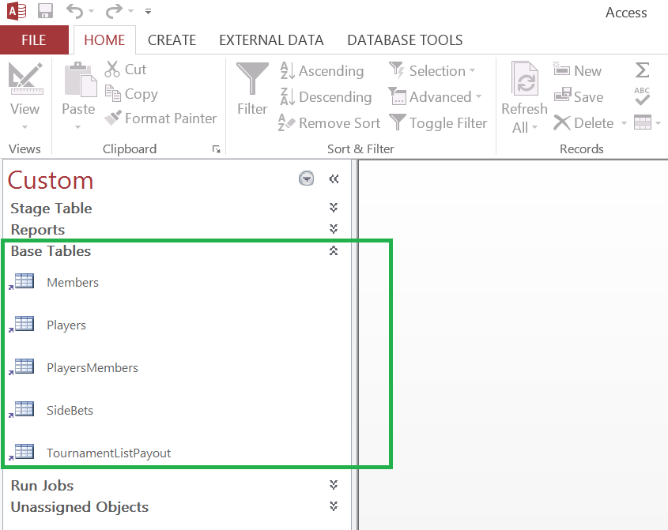

The base tables are in the Navigation Group called “Base Tables” in the MS Access Program. These tables are normally only required to be updated once a year at the beginning of the season. There are 5 base tables:

**Members**: - Used to put in the fantasy golf participant/teams names, pick order, email address. It also auto assigns a unique key number (ID) used for program jobs and reports.

**Players**: - Used to put in the PGA player names that will be used to match up when loading results from pgatour.com. It also auto assigns a unique key number (ID) used for program jobs and reports.

**PlayersMembers**: Used to assign a member to players and assigned the pick order number.

**SideBets**: Used to assign side bets between players.

**TournamentListPayout**: Used to assign payout amount and schedule for the fantasy golf year.